# GAM306 Game Design II

Assessment One

# Design Brief TWO

**Middle-eastern environment for Steal Shooter game**

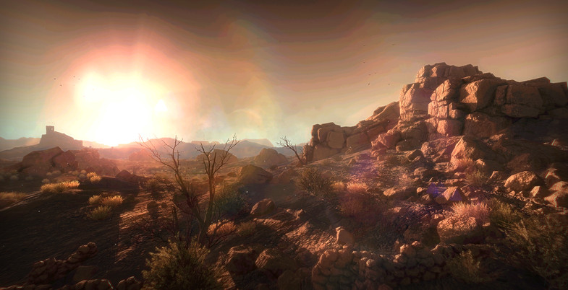

* Similar genre to games like *Sniper Elite* and *Metal Gear Solid*
* Consider;
  + Players need hiding locations
  + Hide spots need to be balanced – there must be open, exposed areas where the player will need to time their movements so as to avoid detection
  + There needs to be locations for AI – guards patrolling etc., that can spot the player and end the stealth status

# Requirements

**Deadline**: 2 weeks (DUE in-class in week 4), plus possible minor adjustments after feedback

**Resources**: Unity asset package*: Middle-East Environment.unitypackage* – provided in class

**Scope**: Must be of small scale. Build enough content to allow for a single gameplay moment from a *Stealth Shooter*. For example:

* The player needs to infiltrate an enemy compound in order to steal an intelligence package. The compound is a simple military outpost with two watch towers, a chain-link fence, and a small creek running behind the fence. The player starts behind a boulder near the creek, and must sneak approximately 25 meters along the creek, timing their approach to coincide with the walking patterns of the guards in the watch towers. The player will need smaller boulders, trees and other foliage, to use as cover while approaching the base.

**Setting:** May be entirely natural environment, a built environment, or a mix

**Submission:**

* Week 4: in-class demonstration for feedback.
* Week 6: published game (.exe and _data folder) and .PDF document briefly explaining how you responded to this brief.